29.29: a) The induced electric field lines are concentric circles since they cause the current to flow in circles.
b)
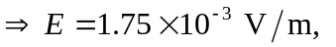in the clockwise direction, since the induced magnetic field must reinforce the decreasing external magnetic field.
c) 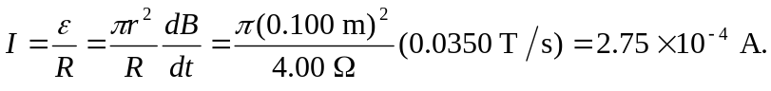
d) 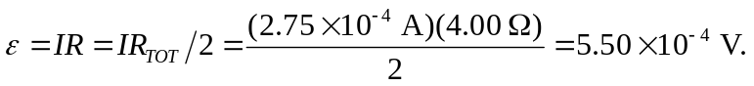
e) If the ring was cut and the ends separated slightly, then there would be a potential difference between the ends equal to the induced emf:
